March 13, 2022
Morning Worship

Message Scripture Nehemiah Chapter 9 Amazing Things Can Happen
When We Confess

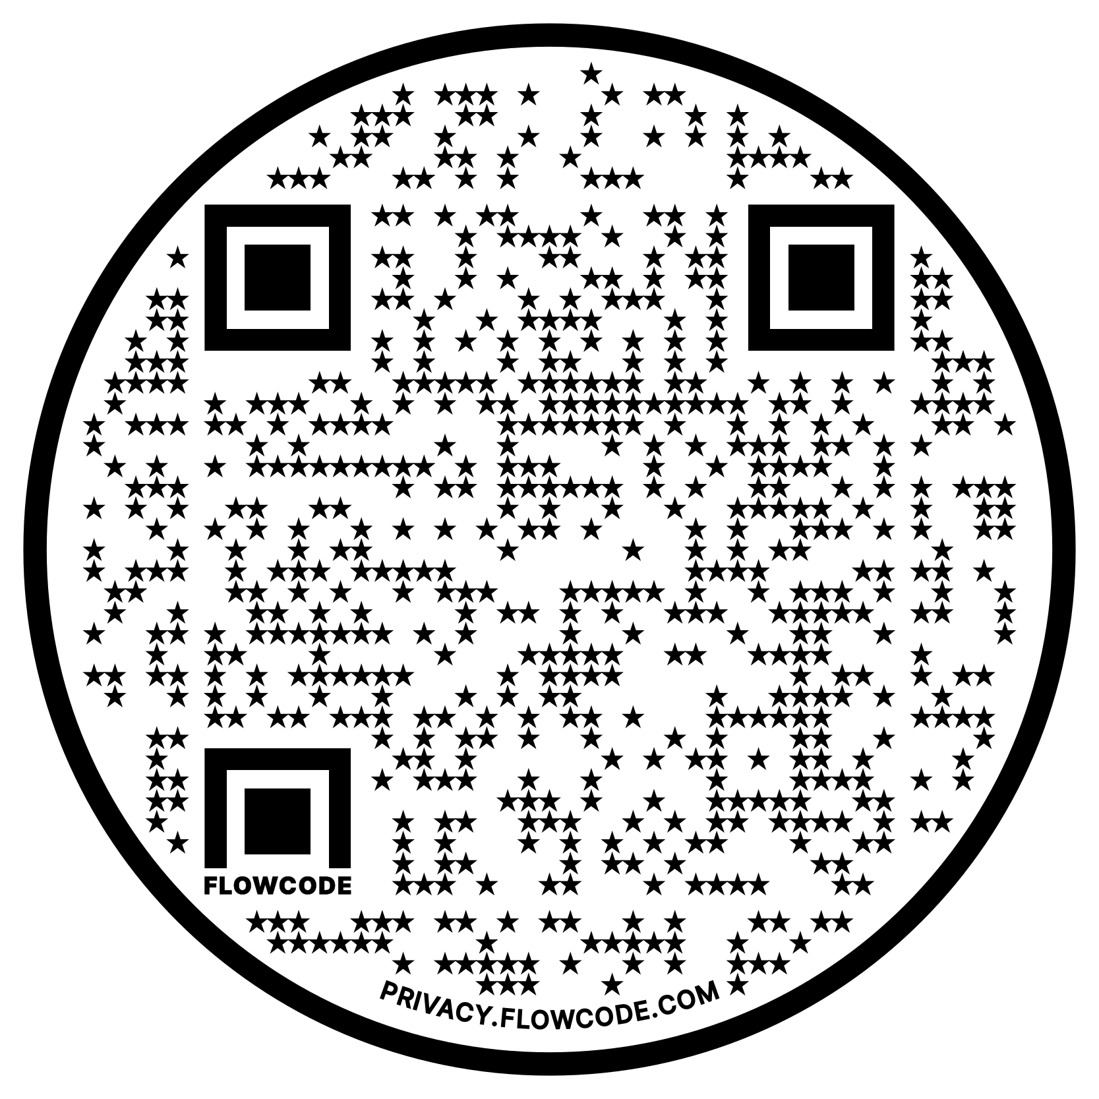
Message Notes Music Playlist

Giving

New World this week:
Mon. – March 14 – 9:00a.m (zoom)– Mon. Morning Men
Mon. – March 14 – 10:00a.m. – Prayer Quilt
Tues. – March 15 – 9:00a.m. – Bible Babes
Thur. – March 17 – 6:30p.m. – Worship Rehearsal - Worship Center
Thur. – March 17 – 6:30p.m. – Grief Share – Unity Class
Thur. – March 17 – 6:30p.m. – Men’s Bible Study – Parlor
Thur. – March 17 – 7:00pm – Yoga
Coming Events:
Mar. 20 – 12:00 – 4:30pm Parent’s Day Out
Contact: Mary Katherine
Mar. 25, - 6:30-8:30 Family Night Sock Hop
Contact: Mary Katherine
Mar. 27 – 12:00-12:45pm – Children’s Choir
Contact: Mariel
Mar. 27 – Soup & Cornbread
This Week’s Reminders:
Mar. 13 - Book Buddy Sign up
Contact: Jodi Ernest
March Office Supply Drive
Contact: Jodi Ernest
Mar. 13-April 6 – Bring filled Easter Eggs

Current Prayer Requests:
Bill Allen, Mike Schmittinger, Betty Kollman,
Zach Batiste, Rick & Pam Arthur, Lyla Kehr, Nathan Simerly, Donna Cherry ’s BIL, Gary, Becky Hays, Mary Rhodes’ sister, Judy, NW Day School staff
& Children

Altar flowers are given by Marilyn McCoy in memory of Jim. His 75th birthday would have been 3/10 and 3/14 will be the 2nd anniversary of his being with his Sovereign God

