May 15, 2022
Sunday Worship

Message
It Gets Better

Church Links
sermon notes, music, giving, calendar

New World this week:
Mon. – May 16– 9:00a.m (zoom)– Mon. Morning Men
Mon. – May 16 – 9:30a.m. -Sit N Sew
Tues. – May 17 – 9:30a.m. – Bible Babes
Tues. & Thurs – May 17 & 19– 7:00p.m. – Yoga - Mini MAC
Thurs – May 19 – (9:30am Zoom) - Pastor’s Bible Study
Thur. – May 19 – 6:30p.m. – Worship Rehearsal
Thur. – May 19 - 6:30p.m. – Men’s Bible Study

Coming Events:
May 15 –12:00 Spanish Sunday School
Contact: Pastor Erendira
May 15– 5:00pm Montclair

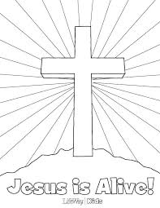

Joys;
Congratulations to Kristen Terry Alford and husband James in the birth of new baby boy, Madden James. Grandparents Beth and James Terry are overjoyed!!

Current Prayer Requests:
Ukraine, Zach Batiste, Cindy Galbaith’s nephew Kyle & friend Brent who are facing health issues, Gerald & Dee Lancaster, Cary Davis, Mike Schmittinger, Betty Kollman, Travis Horne, Townes Hickman, Denise Hickmans’s friend-Lindy, Rick & Pam Arthur, Lyla Kehr, Nathan Simerly, Donna Cherry’s BIL Gary, , Becky Hays, Mary Rhodes’ sister Judy, Keith Scally’s mom, Bill Allen, Mary Murray, Lauren, Ella, Garret,
NW Staff & Day School staff & Children

