May 1, 2022
Sunday Worship

Message
The Good Life

Church Links
sermon notes, music, giving, calendar

New World this week:
Mon. – May 2 – 9:00a.m (zoom)– Mon. Morning Men
Mon. – May 2 – 10:30a.m. -Sit N Sew
Tues. – May 3 – 9:30a.m. – Bible Babes
Tues. & Thurs – May 3 & 5– 7:00p.m. – Yoga - Mini MAC
Thur. – May 5 – (Zoom) - Pastor’s Bible Study
Thur. – May 5 – 6:30p.m. – Worship Rehearsal
Thur. – May 5 - 6:30p.m. – Men’s Bible Study

Coming Events:
May 1 –12:00 Spanish Sunday School
Contact: Pastor Erendira
May 1 – 5:00pm Montclair

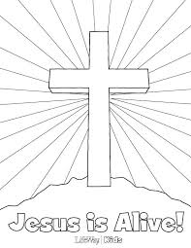

Altar Flowers
Altar flowers are placed by C.F. and Kay Pratt in celebration of the 58th wedding anniversary.

Current Prayer Requests:
Ukraine, Zach Batiste, Cindy Galbaith’s nephews Kyle & Brent who are facing health issues, Gerald & Dee Lancaster, Cary Davis, Mike Schmittinger, Betty Kollman, Rick & Pam Arthur,
Lyla Kehr, Nathan Simerly, Donna Cherry’s BIL Gary, Emily Cherry Oliver, Becky Hays, Mary Rhodes’ sister Judy, Keith Scally’s mom, Bill Allen, Mary Murray, Lauren, Ella, Garret,
NW Staff & Day School staff & Children
c

