April 3, 2022
Morning Worship

Message Scripture Nehemiah Chapter 13 Amazing Things Can Happen
Despite Us

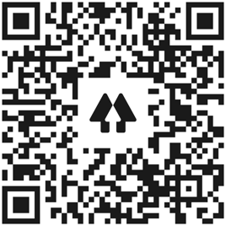

Church Links
sermon notes, music, giving, calendar

New World this week:
Mon. – April 4– 9:00a.m (zoom)– Mon. Morning Men
Mon. – April 4 – 9:30a.m. – Sit N’ Sew
Tues. – April 5– 9:30a.m. – Bible Babes
Wed. – April 6 – 6:00p.m.- Bells: 7:00p.m.- Choir
Tues. & Thurs – April 5 & 7– 7:00p.m. – Yoga - Mini MAC
Thur. – April 7– 6:30p.m. – Worship Rehearsal - Worship Center
Thur. – April 7– 6:30p.m. – Grief Share – Unity Class
Thur. – April 7- 6:30p.m. – Men’s Bible Study
Sat. – April 9- 8:00a.m. – UMM Breakfast
Sat. – April 9 - 9am-3pm. – Work Day
Coming Events:
TODAY:
April 3- 11:45 Soup & Cornbread
April 3- 12:00 Children’s Choir
April 3 –12:00 Spanish Sunday School
Contact: Pastor Erendira

April 9 – 8:00am – UMM Breakfast
April 9 – 9:00-3:00 – All Church Work Day
April 10- 12:30 Easter Egg Hunt
April 11 – 6:30pm – Administrative Board

Easter Sunday Schedule
7:00am – Sunrise Service
9:30am – Breakfast
10:45am – Easter Worship Service

Current Prayer Requests:
Zach Batiste, Jean Potter & Family,
Mike Schmittinger, Betty Kollman, Rick & Pam Arthur,
Lyla Kehr, Nathan Simerly, Donna Cherry’s BIL Gary,
Becky Hays, Mary Rhodes’ sister Judy,
NW Day School staff & Childrenc

